Does Religiousness Matter toward Intention to Commit Digital Piracy?
Adhika Putra Wicaksono^{1*}
¹ University of Surabaya, Indonesia
*Corresponding author. Email: adhikaputraw@staff.ubaya.ac.id
ABSTRACT
The purpose of this study is to examine digital piracy using Theory of Planned Behavior (TPB), religious theory, and deterrence theory by also adding economic benefits and hedonic benefits. This study used a non-probability sampling technique. The questionnaire was distributed through an online platform and obtained 214 respondents. The data acquired from the respondents used SPSS 23 and AMOSS 21 to process the Structural Equation Model (SEM). The results of this study stated that attitude toward digital piracy and perceived behavioral control positively influence consumer intention to commit digital piracy. The results also stated that attitude toward digital piracy positively influenced by hedonic benefit and extrinsic religiousness. According tothe results of this study, government and the film industry must change the way Indonesian consumers perceive about digital piracy so that the number of digital piracy in Indonesia can decrease.
Keywords: Theory of Planned Behavior, Digital Piracy, Religiousness, Consumer Behavior, Indonesia.

1. Introduction
One of the biggest problems facing the music, film and software industries is digital piracy [1]. Digital piracy is an illegal act of copying, downloading, uploading, sharing, and distributing digital media (audio products, videos, books, and images) without the permission of the copyright holder [2]. Digital piracy is most vulnerable to developing countries such as China and Indonesia [3]. The factors that cause the rate of digital piracy in developing countries are low average income, high unemployment rate, lack of strict law enforcement, and low moral obligation of society. [3-5]. In fact, the impact of digital piracy is bigger and more complex in developing countries [6].
Interestingly, apart from the high rate of digital piracy (which is an unethical act), developing countries such as Bangladesh, Indonesia, Sri Lanka, and Nigeria also have high levels of community religiosity. [7]. Previous research still states that the results are not uniform regarding the influence of a person's level of religiosity on attitudes and intentions to behave unethically [8-10]. Vitell et al. (2005) stated that religiosity reduces a person to behave unethically. Meanwhile, according to Barna (2004) and Casidy et al. (2016), a person's higher level of religiosity does not result in lower levels of digital piracy.
Due to the Covid-19 pandemic, the Indonesian film industry experienced a 97% decline in revenue [11]. This is due to large-scale social restriction regulations that require non-essential public facilities, including cinemas, to be closed to suppress Covid-19 cases. In fact, 90% of Indonesia's film industry revenue comes from cinema tickets. Even though many digital platforms and streaming services have emerged as a medium for watching movies, on the other hand, illegal movie streaming services are still rampant and trigger film piracy. Piracy has hurt the film industry long before the emergence of the Covid-19 pandemic. The pandemic has further exacerbated the loss of the film industry. Indonesian Film Producers Association/ Asosiasi Produser Film Indonesia (APROFI), reported that in 2020 the loss of the film industry due to film piracy was 350 million USD. The Indonesian government has tried to reduce the number of film piracy by blocking around 1,745 illegal sites from 2017 to 2020, but these efforts have been to no avail. This is because even though many illegal sites have been blocked, there are still many new illegal sites that have sprung up [12].
Many previous studies have investigated digital piracy. For examples include research in the context of digital piracy in general [7, 9, 13-16], music piracy [1, 17], software piracy [6, 18-20], and pirated video game [21]. Furthermore, different theories have been used to research digital piracy such as the theory of planned behavior (TPB) [6, 18, 21], religiousity theory [4, 7, 9], and detterence theory [3, 20].
Of the many studies that have been carried out, there are still very few researchers who are interested in comparing these theories in one study. Therefore, this study wants to examine digital piracy using TPB, religiousity theory, and deterrence theory by also adding economic benefits and hedonic benefits. More specifically, this study will only examine one form of digital piracy, namely film piracy in Indonesia. This is interesting to study because the Indonesian film industry is very affected by film piracy, whereas on the other hand, Indonesian society is a religious society.
2. research methods
This research used quantitative approach. Based on the objectives, this research used casual research because it aimed to testing casual relationship between variables. Population of this study is gen z who know and ever did digital film piracy. The characteristics of the population determined are gen z who ever did digital piracy, male or female, minimum 16 years old, maximal 26 years old, and at least possess high school education or equivalent.
The questionnaire was distributed through an online platform and obtained as many as 214 respondents. The data obtained from the respondents were processed using SPSS 23 and AMOSS 21 to process the Structural Equation Model (SEM).
There are 9 variables in this study, that is Hedonic Benefit (HDN), Economic Benefit (ECB), Intrinsic Religiousness (INR), Extrinsic Religiousness (EXR), Perceived Likehood of Punishment (PLP), Subjective Norms (SBN), Attitude towards Digital Piracy ( ADP), and Intention to Commit Digital Piracy (ICD). Initially there were 47 measurement items proposed, but after the validity and reliability tests were carried out on SPSS, only 34 items were declared valid and reliable (HDN 5 items, ECB 3 items, INR 2 items, EXR 2 items, PLP 5 items, PBC 5 items, ADP 8 items, and ICD 3 items). Figure 1 shows the model of this research.
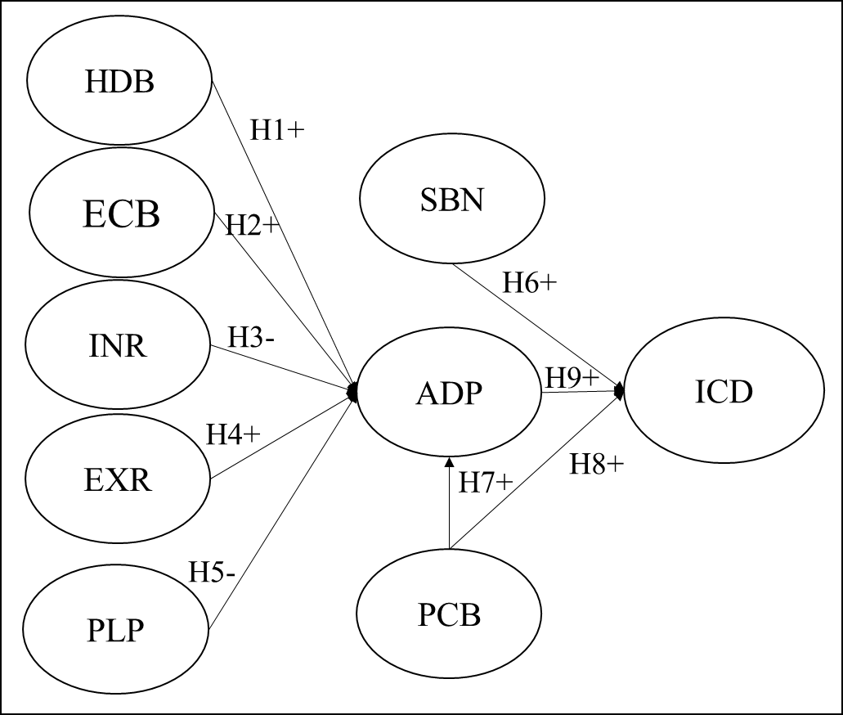
Figure 1. Research Model
3. results and discussion
3.1 Respondent’s Profile
There were a total of 214 respondents who filled out the questionnaire in this study, which were dominated by male (54,67%), Muslim (36,92%), having a high school education (84,58%), and earning less than Rp. 500,000 (53,74%). All respondents are gen z aged between 16-26 years, where gen z is one of the groups (besides millennials) with the highest level of technology use [22].
Table 1. Respondent’s Profile
Criteria | Demographics | n | %
Gender | Male | 117 | 54,67
 | Female | 97 | 45,33
Religion | Islam | 79 | 36,92
 | Christian | 71 | 33,18
 | Catholic | 45 | 21,03
 | Hindu | 4 | 1,87
 | Buddha | 14 | 6,54
 | Others | 1 | 0,47
Last | Undergraduate | 33 | 15,42
Education | Senior High School | 181 | 84,58
Income | < 500.000 | 115 | 53,74
(Rupiah) | > 10.000.000 | 6 | 2,80
 | 5.000.001 - 10.000.000 | 5 | 2,34
 | 500.001 - 1.000.000 | 55 | 25,70
 | 1.000.001 - 5.000.000 | 33 | 15,42

3.2 Validity and Reliability Test Results
After calculating the Pearson Correlation and Cronbach's Alpha on SPSS, all variables and indicators were declared valid (Pearson Correlation < 0.05) and reliable (Cronbach's Alpha > 0.6).
3.3 Measurement Models
As shown in Table 2, the measurement model match test of Confirmatory Factor Analysis (CFA) results showed that one index were classified as a good fit and four were classified as a marginal fit.
Table 2. Model Fit Test of CFA
No. | Match Testing | Criteria | Results | Description
1 | CMIN/DF | ≤ 2,00 | 2,135 | Marginal fit
2 | GFI | ≥ 0,90 | 0,775 | Marginal fit
3 | RMSEA | ≤ 0,08 | 0,073 | Good fit
4 | TLI/NNFI | ≥ 0,90 | 0,869 | Marginal fit
5 | CFI | ≥ 0,90 | 0,885 | Marginal fit
Table 3 shows the Average Variance Extracted (AVE) and Construct Reliability (CR) values. However, before calculating the AVE and CR, it is necessary to evaluate the standard loading value, where the standard loading value must have a value > 0,50. The AVE value must be > 0,50 and CR value must be > 0,70 [23]. After processing the data, it is known that all constructs have standard loading > 0.50; AVE > 50; and CR > 0.70. Thus, it can be stated that all research constructs are declared valid and reliable.
Table 3. AVE and CR of the Construct
Variable | AVE | CR
Hedonic Benefit | 0,509 | 0,837
Economic Benefit | 0,557 | 0,789
Intrinsic Religiousness | 0,575 | 0,726
Extrinsic Religiousness | 0,516 | 0,681
Perceived Likehood of Punishment | 0,538 | 0,822
Perceived behavioral control | 0,610 | 0,886
Subjective norms | 0,551 | 0,709
Attitude towards digital piracy | 0,681 | 0,944
Intention to commit digital piracy | 0,845 | 0,942

3.4 Structural Models
Structural analysis model is used to determine the effect between research variables or the results of hypothesis testing. The constructs that can be used in the analysis of structural models are constructs that have a significant estimation value of the variable to be measured. Variables that have significance to other variables can be determined from the p value less than 0.050. As shown in Table 2, the measurement model match test of structural model results showed that one index were classified as a good fit and four were classified as a marginal fit.

Table 4. Model Fit Test of Structural Model
No. | Match Testing | Criteria | Results | Description
1 | CMIN/DF | ≤ 2,00 | 2,120 | Marginal fit
2 | GFI | ≥ 0,90 | 0,774 | Marginal fit
3 | RMSEA | ≤ 0,08 | 0,720 | Good fit
4 | TLI/NNFI | ≥ 0,90 | 0,871 | Marginal fit
5 | CFI | ≥ 0,90 | 0,885 | Marginal fit
3.5 Hypothesis Testing
Table 5 summarizes the hypothesis testing results of the proposed model. The results demonstrated that not all hypotheses were supported and significant. A hypothesis is supported and has a significant value if the p-value is less than 0.05. There were five supported hypotheses, i.e., H1, H4, H8, and H9.
Table 5. Summary of Hypothesis Test Results
H | Relationship between constructs | Estimate Value | P | Significance | Supported Hypothesis
1 | HDB ADP | 0,415 | 0,006 | Yes | Yes
2 | ECB ADP | 0,173 | 0,173 | No | Yes
3 | INR ADP | 0,116 | 0,341 | No | No
4 | EXR ADP | 0,575 | *** | Yes | Yes
5 | PLP ADP | -0,053 | 0,666 | No | Yes
6 | SBN ADP | -0,046 | 0,802 | No | No
7 | PCB ADP | 0,044 | 0,604 | No | Yes
8 | PCB ICD | 0,438 | 0,001 | Yes | Yes
9 | ADP ICD | 0,867 | *** | Yes | Yes
4. DISCUSSION
This study indicate that the higher hedonic benefit, the higher consumer’s attitude toward digital piracy. This is in line with previous studies [1, 24]. The purchase and consumption of counterfeit products is seen by the final consumer as a pleasurable act that provides pleasure and emotional satisfaction. The excitement of committing illegal acts, both offline and online, drives digital piracy behavior. Therefore, the hedonic benefits offered by pirated products result in a positive attitude towards piracy attitudes.
This study shows that extrinsic religiousness has a positive influence on attitudes toward digital piracy. This is in line with previous studies [4, 8, 25]. Research conducted by Vitell et al. (2005) showed that extrinsic religiousness has no effect on consumer ethics. Individuals with high extrinsic religiousness may be ethically insensitive compared to individuals who have high intrinsic religiousness and are more likely to accept digital piracy and tend to be less afraid of legal consequences [4].
This study indicate that the higher consumer’s perceived behavioral control, the higher consumer’s intention to commit digital piracy. This is in line with previous studies [4, 26, 27]. Perceived control describes how an individual's beliefs about behavior and the difficulty of doing something. when consumers perceive themselves to have more control in unethical situations (e.g. digital piracy), they are more likely to commit in digital piracy [27]. In the context of film piracy in Indonesia, there are many illegal websites that provide free viewing of pirated films. This makes it very easy for Indonesian people to commit film piracy. The government is not without action in eradicating illegal websites that provide pirated films. The Indonesian government has eradicated many illegal websites providing pirated films. However, there are more and more illegal websites providing pirated films.
This study indicate that the higher consumer’s attitude toward digital piracy, the higher consumer’s intention to commit digital piracy. This is in line with previous studies [1, 4, 18, 27, 28]. Attitude is the best predictor of intention, which can also be used to predict behavior. Therefore, a good attitude towards an action must be consistent with the behavior, while a negative attitude makes a person refrain from performing a behavior [1, 29]. Based on the SEM test, it is known that attitude toward digital piracy has the greatest positive influence on intention to commit digital piracy (0.867). Therefore, it is important for the government and related parties to the film business in Indonesia to change consumer attitudes towards digital piracy. Consumers in developing countries such as Indonesia are still positive about piracy. This has hampered efforts to reduce film piracy.
5. CONCLUSION
This study examine the attitudes and intentions toward movie digiral piracy in Indonesia. This study developed factor affecting the addtitudes and intentions of gen Z by considering multiple theories, i.e. TPB, religiousity theory, and detterence theory by also adding economic benefits and hedonic benefits factors. The results of this study stated that attitude toward digital piracy and perceived behavioral control positively influence consumer intention to commit digital piracy. The results also stated that attitude toward digital piracy positively influenced by hedonic benefit and extrinsic religiousness.
Based on the results of the study, the factors that influence the rise of digital piracy in developing countries, especially in Indonesia, are hedonic benefits, perceived behavioral control, and attitude toward digital piracy. The high number of cases of film piracy in Indonesia is due to the large number of illegal websites and the absence of strong law enforcement from the Indonesian government. This makes it easier for Indonesian consumers to piracy films.
Good cooperation is needed between the Indonesian government and parties related to the film industry to be able to eradicate film piracy. Based on the results of this study, one thing that can be done is to change the way Indonesian consumers perceive digital piracy. Indonesian consumers should be educated about digital piracy that digital piracy is an unethical act and can harm many parties.
REFERENCES
[1] L. Cesareo and A. Pastore, "Consumers’ attitude and behavior towards online music piracy and subscription-based services," Journal of Consumer Marketing, 2014.
[2] S. Yu, "Digital piracy justification: Asian students versus American students," International Criminal Justice Review, vol. 23, no. 2, pp. 185-196, 2013.
[3] D. Arli and F. Tjiptono, "Consumer digital piracy behaviour among youths: insights from Indonesia," Asia Pacific Journal of Marketing and Logistics, 2016.
[4] D. Arli, K. Kubacki, F. Tjiptono, and S. Morenodiez, "Religiousness and digital piracy among young consumers in an emerging market," Young Consumers, 2017.
[5] S. A. Rotondo, "Piracy as Media Practice: The Informal Market of Music and Videos in Peru," in Piracy and Intellectual Property in Latin America: Routledge, 2020, pp. 70-89.
[6] H. Aleassa, J. M. Pearson, and S. McClurg, "Investigating software piracy in Jordan: An extension of the theory of reasoned action," Journal of business ethics, vol. 98, no. 4, pp. 663-676, 2011.
[7] D. Arli, F. Tjiptono, R. Casidy, and I. Phau, "Investigating the impact of young consumers’ religiosity on digital piracy," International journal of consumer studies, vol. 42, no. 6, pp. 792-803, 2018.
[8] S. J. Vitell, J. G. Paolillo, and J. J. Singh, "Religiosity and consumer ethics," Journal of business ethics, vol. 57, no. 2, pp. 175-181, 2005.
[9] R. Casidy, I. Phau, and M. Lwin, "Religiosity and digital piracy: An empirical examination," Services Marketing Quarterly, vol. 37, no. 1, pp. 1-13, 2016.
[10] G. Barna, "Fewer than 1 in 10 teenagers believe that music piracy is morally wrong," Barna Update, April 26, 2004.
[11] A. Hakim, "Di Balik Layar: Bagaimana Pembajakan Digital Melukai Industri Film Indonesia (Behind the Scenes: How Digital Piracy Hurts Indonesia's Film Industry)," March 9th 2022 2022, Available: https://tekno.kompas.com/read/2022/03/09/10020057/di-balik-layar-bagaimana-pembajakan-digital-melukai-industri-film-indonesia?page=all, Accessed on: April 20th 2022.
[12] F. A. Farisi, "The Impact of Film Piracy to Customer Behavior Toward Indonesian Film Market," International Journal of Business and Technology Management, vol. 3, no. 3, pp. 92-101, 2021.
[13] T. P. Cronan and S. Al-Rafee, "Factors that influence the intention to pirate software and media," Journal of business ethics, vol. 78, no. 4, pp. 527-545, 2008.
[14] Ł. Tomczyk, "Evaluation of digital piracy by youths," Future Internet, vol. 13, no. 1, p. 11, 2021.
[15] Y. Sang, J.-K. Lee, Y. Kim, and H.-J. Woo, "Understanding the intentions behind illegal downloading: A comparative study of American and Korean college students," Telematics and Informatics, vol. 32, no. 2, pp. 333-343, 2015.
[16] K. Y. Koay, F. Tjiptono, and M. S. Sandhu, "Predicting consumers' digital piracy behaviour: does past experience matter?," International Journal of Emerging Markets, 2021.
[17] W. Hampton-Sosa, "The access model for music and the effect of modification, trial, and sharing usage rights on streaming adoption and piracy," Journal of theoretical and applied electronic commerce research, vol. 14, no. 3, pp. 126-155, 2019.
[18] Y. Akbulut, "Exploration of the antecedents of digital piracy through a structural equation model," Computers & Education, vol. 78, pp. 294-305, 2014.
[19] X. Zhang, W. T. Yue, and W. Hui, "Software piracy and bundling in the cloud-based software era," Information Technology & People, 2019.
[20] A. Nill, J. Schibrowsky, and J. W. Peltier, "Factors that influence software piracy: a view from Germany," Communications of the ACM, vol. 53, no. 6, pp. 131-134, 2010.
[21] I. Phau and J. Liang, "Downloading digital video games: predictors, moderators and consequences," Marketing Intelligence & Planning, 2012.
[22] B. Baykal, "Generational Differences in Omnichannel Experience: Rising New Segment: Gen Z," in Managing Customer Experiences in an Omnichannel World: Melody of Online and Offline Environments in the Customer Journey: Emerald Publishing Limited, 2020.
[23] J. F. Hair, "Black, Wc, Babin, Bj, & Anderson, Re (2010)," Multivariate data analysis, vol. 7, pp. 77-95, 2010.
[24] B. Yoo and S.-H. Lee, "Buy genuine luxury fashion products or counterfeits?," ACR North American Advances, 2009.
[25] M. J. Donahue, "Intrinsic and extrinsic religiousness: The empirical research," Journal for the Scientific study of Religion, vol. 24, no. 4, pp. 418-423, 1985.
[26] P. Alleyne, S. Soleyn, and T. Harris, "Predicting accounting students’ intentions to engage in software and music piracy," Journal of Academic Ethics, vol. 13, no. 4, pp. 291-309, 2015.
[27] P. B. Gupta, S. J. Gould, and B. Pola, "“To pirate or not to pirate”: A comparative study of the ethical versus other influences on the consumer’s software acquisition-mode decision," Journal of Business Ethics, vol. 55, no. 3, pp. 255-274, 2004.
[28] D. Arli, F. Tjiptono, and R. Porto, "The impact of moral equity, relativism and attitude on individuals’ digital piracy behaviour in a developing country," Marketing Intelligence & Planning, 2015.
[29] I. Ajzen, "The theory of planned behavior," Organizational behavior and human decision processes, vol. 50, no. 2, pp. 179-211, 1991.

