
DOI: https://doi.org/10.38035/jim.
Received: xx Juni 202x, Revised: xx Juni 202x, Publish: xx Juli 202x
https://creativecommons.org/licenses/by/4.0/

Acceptance and Commitment Therapy Effectivity towards Parents Stress – Meta Analysis

Kezia Jeni Hindrawan^{1*}, Ananta Yudiarso²
Program Magister Psikologi Profesi, Fakultas Psikologi, Universitas Surabaya
Email: keziajenih@gmail.com¹, ananta@staff.ubaya.ac.id²

Corresponding Author: Kezia Jeni Hindrawan

Abstract: Background: Stress in parents inhibits their abilities to optimize parenting role. Acceptance and Commitment Therapy (ACT) helps parents to embrace their feelings and thoughts to be more committed in achieving well-being. Objective: This study aims to analyze the effectiveness of ACT to reduce stress in parents. Method: This research use meta-analytical method from RCT studies to provide in-depth analysis. Results: Result shows a large effect of ACT toward stress intervention within parents particularly in group-based format (I² = 93.01%). Conclusion: This research has given significance proof to use ACT in order to reduce stress within parenting context. Further research should be focused on ACT intervention in Asian parents context with RCT, especially Indonesia.

Keyword: Acceptance and Commitment Therapy, Parents, Stress, Randomized Controlled Trials (RCT).

INTRODUCTION
Research about human development has been developing over years, keeping up with the latest era to provide up-to-date treatment. The role of parenting has been mainly discussed as this thing is stated to play an important role in children’s development. Daily demands parents face lead to stress, which happens when resources do not meet their needs, either for the family nor themselves (Gouveia et al., 2016). Abidin (in Chung et al., 2020) explained about Parental Stress Model, in which stress in parents is the result of perception towards stressor or, once again, demands related to parenting. Previous studies have proved that stress in parents of disabled children rates higher than typical ones (Samadi et al., 2014: Craig et al., 2016; Barroso et al., 2017; Chodidjah & Kusumasari 2018; Lu et al., 2018; Holly et al., 2019). It is important for clinicians to pay attention to this matter, as stress in parents correlates with their ability to choose the best options for their children’s treatment and development, thus optimizing parenting roles.
There are several methods to decrease the degree of stress in parents. One of the latest treatments is using Acceptance and Commitment Therapy (ACT), as a combination of cognitive and behavior intervention to reach mindfulness. This intervention is within the Applied Behavior Analysis (ABA) field with psychological flexibility as its main goal. ACT has 6 domains : contact with present moment, defusion, acceptance, self-as context, values, and last, committed actions. Clients are asked to settle and accept their own thoughts and feelings as part of themselves, at last take commitment to reach a better life according to each individual's values of life (Harris, 2019).
In parenting context, ACT will ask parents to find their values of life overall and parenting, and to be present at the moment to be able to make decisions and be committed for change according to their values, also to take healthy boundaries for the soul (Prevedini et al., 2020). Coyne & Murrell stated the approach of cognition and emotion regulation for parents is the key for successful parenting, and this is what ACT believes (Wardani et al., 2017).
This study aims to discover whether ACT intervention has effectively decreased stress in parents. Previous studies has conducted systematic reviews and meta analytic about ACT and stress toward family caregiver (Han et al., 2021) and parents of children with developmental disability (Chua & Shorey, 2021) but with general outcome, but there is no study which discussed ACT impact specifically on stress in parents of children in general. The other novelty of this study is using Controlled Trial as one of the inclusion criteria. This is to compare the effectiveness of ACT more accurately rather than single case. This study hypothesized that ACT is effectively decreasing stress in parents, whether from children of disabilities nor typical.

METHOD
This meta-analytic review is conducted according to Preferred Reporting Items for Systematic Reviews and Meta-Analyses (PRISMA) Guideline 2020. Research journals were searched through Google Scholar, Sciencedirect, and Elicit, with key terms “ACT and parent stress RCT” ; “Acceptance Commitment Therapy and Stress RCT”; “Stress Intervention in Parent RCT”; “Mother Stress Intervention RCT”. The inclusion criterias are : (1) controlled trials about impact of Acceptance and Commitment Therapy towards stress in parents, both or individual (father/mother only), from typical or non-typical children; (2) latest 10 years (2013-2023); (3) does not include waitlist control (WLC) group which had post-result after given the intervention. Research with WLC is accepted if this control group is given the intervention after follow-up session of the experiential group. This is to make sure the control group was purely not given ACT to compare the effectiveness of methods specifically. ACT is a new intervention, therefore it is important to keep up with the latest data. The exclusion criterias for this research are : (1) does not discuss ACT effectiveness toward stress in parents; (2) conducted before 2014; (3) single-group or RCT but with WLC which post-test score was taken after being given ACT intervention; (4) controlled group was given ACT intervention in different time or method (e.g. web-based self-help and guided by therapist).

Identification of studies via databases and registers

Records removed before screening:
Duplicate records removed (n = 2)
Records marked as ineligible by automation tools (n =492 )
Records removed for other reasons (n = 58)
Records from Google Scholar:
Databases (n = 145)
Records from Science Direct
Databases (n = 441)
Research from PubMed
Databases (n = 3)

Identification

Records excluded
Single-Group / RCT but WLC which post test score was taken after ACT (n = 5)
Not in Indonesian / English (n = 4)
Before 2014 (n = 11)
Records screened
(n = 37)

Screening
Reports sought for retrieval
(n = 20)

Reports assessed for eligibility
(n = 18)

Included
Studies included in review
(n = 9)

Figure 1. Research Model using (PRISMA) Guideline 2020

RESULT AND DISCUSSION
After conducting a thorough search, the researchers identified nine studies that met the inclusion criteria. A meta-analytical test was performed using Jamovi 2.3.21. The following is a list of studies included in this research for meta-analytical evaluation.
Table 1. List of Research Journals and Results
Author (Year) | Measurement of Stress | Method | Control Group Treatment | I² | 95% CL
 |  |  |  |  | UB | LB
Corti et al (2018) | PSI | 12-sessions group format every 2 weeks in 1.5 hour/session | No treatment | 0.40 | -0.21 | 1.01
Marino et al (2021) | PSI-SF | Group based in 24 weeks | Parent Training | 1.60 | 0.89 | 2.31
Sairanen et al. (2019) | DASS-21 (Stress) | Individual web-based in 10 weeks | No treatment | 0.14 | -0.44 | 0.72
Brown et al., (2015) | DASS-21 (Stress) | Group-based | Care-as-  usual | 0.60 | 0.08 | 1.12
Chong et al (2019) | DASS-21 (Stress) | 4 weekly sessions of group-based ACT integrated with asthma education | Family counseling and asthma education | 3.73 | 3.23 | 4.23
Whittingham et al (2015) | DASS-21 (Stress) | 2-hour group-based | SSTP | 0.48 | -0.11 | 1.08
Thomas & Mathew (2023) | PSS | Individual 24 sessions | CBT | 1.61 | 0.60 | 2.62
Joekar et al. (2016) | DASS-21 (Stress) | 8-week group based | Treatment as usual | 1.10 | 0.24 | 1.96
Maughan et al (2023) | DASS-21 (Stress) | 3 sessions group Workshops | No treatment | 2.10 | 1.44 | 2.77

Table 2. Heterogeneity Statistics
Tau |  | Tau² |  | I² |  | H² |  | R² |  | df |  | Q |  | P
1.185 |  | 1.4043 (SE= 0.8154 ) |  | 93.01% |  | 14.310 |  | 0% |  | 8.000 |  | 134.398 |  | < .001
Tau | Tau² | I² | H² | R² | df | Q | P
1.185 | 1.4043  (SE = 0.8154) | 93.01% | 14.310 | 0% | 8.000 | 134.398 | <.001

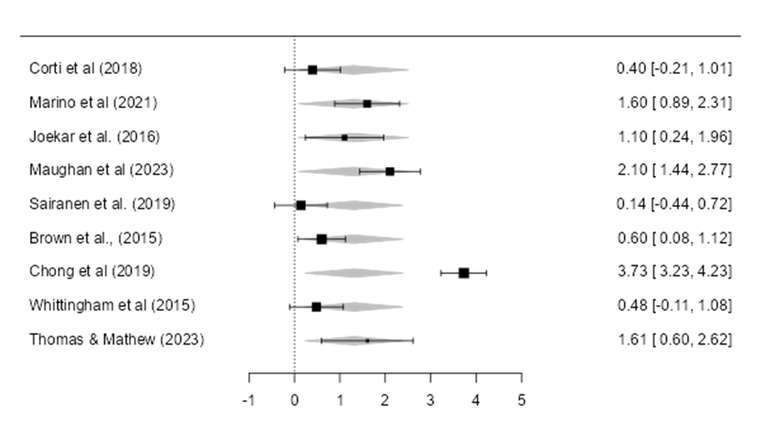
Figure 2. Forest Plot
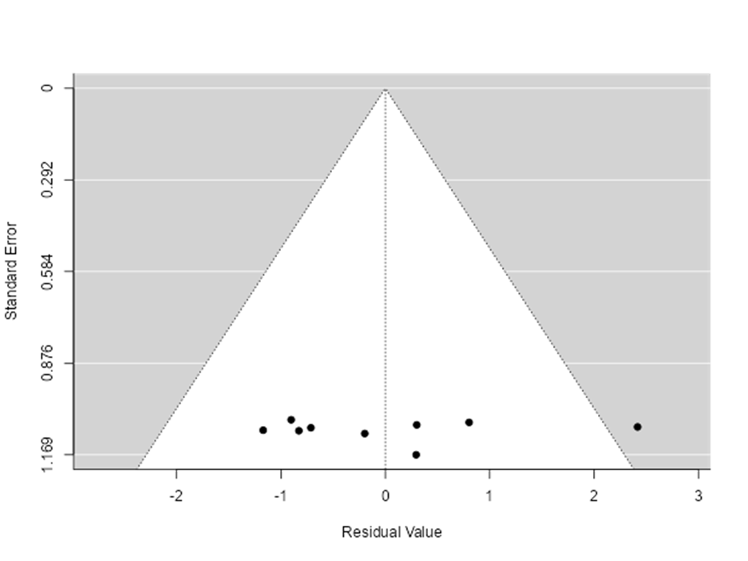
Figure 3. Standardized Mean Differences

As shown from Figure 2, data is significant statistical heterogen with I2 = 92.1% (≥80%) therefore a random effect test is conducted. Figure 3 shows an effect size of 1.31 as a large effect size group. This means ACT has a big impact on reducing stress in parents. Table 1 shows most studies use DASS-21 to measure stress in parents, since this measurement could look up not only the stress aspect but also depression and anxiety intensity as well. However in this study the authors solely focus on the Stress aspect of DASS-21. Parents of autistic children are often used as participants of ACT Intervention experiments to reduce stress. Study of Chong et al (2019) shows a highest lower bound and upper bound, which means this study has the largest score of effectiveness using ACT to reduce parents' stress. Eager regression score of 0.960 (p > .01) shows no publication bias to this analysis.

Discussion
This review shows ACT has a high probability of success in reducing parents’ stress (I2 = 92.1%) compared to other treatments such as parent training, CBT, counseling, care-as-usual, or even with no intervention given. This is different from previous similar studies about ACT effect toward stress in family caregivers by Han et al. (2021), which only showed a small effect compared to control groups (SMD = 0.30) and moderate effect in pretest-posttest design (SMD = 0.54). Chua & Shorey (2021) meta analytical review also shows a moderate impact of ACT and Mindfulness-Based Intervention at decreasing depression, stress, and anxiety among parents of developmental disabilities children with no significant differences. This becomes a novelty of present’s meta analytical study.
ACT intervention focuses on psychological flexibility which helps parents to find their own internal resources to handle problems (Marino et al., 2021, Thomas & Matthew, 2023). Keypoint of ACT is asking parents to embrace their own feelings and thoughts instead of denying or fighting their existences, even more feeling guilty (Thomas & Matthew, 2023). The process was relaxing and positive, thus helping parents to have a sense of competence to face stressful situations (Maughan et al., 2023) and understanding their children’s situations. Moreover, the feeling of competence also decreases parents' perception of children’s disruptive behavior such as oppositional, noncompliance, tantrum, and aggression (Marino et al, 2021). This explanation represents causes of significant effectiveness of ACT towards declining scores of parents’ stress.
Table 1 shows studies with large effect size (I² > 0.8) has group-based ACT interventions, with study conducted by Thomas & Matthew (2023) as the only exception which used individual sessions but in a longer period. This finding indicates ACT intervention works more effectively in group format, thus more commonly conducted than individual sessions. This format provides parents a space to share experiences one to another as of having positive social support (Maughan et al., 2023). Studies conducted by Chong et al. (2019) and Maughan et al. (2023) show the biggest effect size in this meta-analytical review. Similarities of these studies are using group-based format in moderate length of periods (3 to 4 sessions), also given to parents of children with biological problems. With the help of education related to their children’s condition, parents understand more about their children’s situation and how to handle their symptoms. Study by Marino et al., (2021) with large effect size also provides parent training of parents with autistic children to train participants how to handle their autistic kids. Ambiguity is one of the key factors of stress in individuals. Understanding their situation and how to solve every challenge will help individuals to reach a relaxing condition. This might be the right explanation for why Chong et al achieves the most significant effectiveness of ACT in this study.
On the other hand, studies by Corti et al. (2018) and Brown et al. (2015) show a moderate effect size with similar scores. Both were conducted in group format as well. Why do these studies have different results of effectiveness? First, in Corti et al. (2018), there was a declining mindfulness awareness and no change of cognitive fusion after ACT was given. Authors argued these two aspects need a longer period of time to show changes. In this study, ACT was given to parents whose autistic children started their EIBI (Early Intensive Behavioral Intervention), which probably limited the results of parents' stress score in post-test and at the end did not live up to the authors' expectation. In Brown et al ’s case, ACT was given along with SSTP (The Stepping Stones Triple P). ACT was conducted only in 2 sessions, whereas SSTP in 9 sessions. This may be the reason for lower effectiveness of the ACT role.
The lowest effect size is in Sairanen et al. study using individual web-based. This indicates ACT is better conducted face-to-face with the help of therapist’s guidance in every step of treatment. Web-based ACT provides an easier way for individuals to be treated using this method. However, improvement is needed to create more accurate content in order to optimize treatment. Authors didn’t find the exact weakness of their web intervention, therefore further research is needed.
It is deeply regretted that ACT intervention studies for parents in RCT are still a few. This becomes the main limitation of present review. In context of location, authors didn’t find any suitable study in Indonesia. There was only one study in Indonesia with ACT in mothers but using a single-group with no comparison. Further research should measure the effectiveness of ACT in controlled groups focusing on Indonesia in order to show effectiveness of this intervention in different cultures.

CONCLUSION
The aim of this study is to show how impactful ACT is to decrease stress in parents. This meta analytical review from the last 10 years research shows a large effect size which means ACT has been effectively decreasing stress in parents. Previous meta-analytical study of ACT towards stress shows small to moderate effects. This becomes a novel finding. ACT shows higher effectiveness in group-based with 3 to 4 sessions compared to months or longer periods of time. Combination of education about children’s condition and correct parenting will also help parents to feel more assured to face the stressful situation of their parenting role. DASS-21 has been commonly used to measure parents’ stress intensity since this measurement provides a more holistic view of participants. Further research of ACT toward parents’ stress should be conducted with focus on the Indonesian context.
ACT is a growing field. Studies regarding ACT in parenting context are still limited for the past 10 years. This study shows a significant effectiveness of ACT method to decrease parenting stress. Further studies should be focusing more on comparing web-based and onsite ACT interventions, also varying cultural context especially within Indonesia using controlled groups to show better comparison.

REFERENCES
Barroso, N. E., Mendez, L., Graziano, P. A., & Bagner, D. M. (2018). Parenting Stress through the Lens of Different Clinical Groups: a Systematic Review & Meta-Analysis. Journal of Abnormal Child Psychology, 46(3), 449–461. https://doi.org/10.1007/s10802-017-0313-6
Brown, F. L., Whittingham, K., Boyd, R. N., McKinlay, L., & Sofronoff, K. (2015). Does Stepping Stones Triple P plus Acceptance and Commitment Therapy improve parent, couple, and family adjustment following paediatric acquired brain injury? A randomised controlled trial. Behaviour Research and Therapy, 73, 58–66. https://doi.org/10.1016/j.brat.2015.07.001
Chodidjah, S., & Kusumasari, A. P. (2018). Pengalaman Ibu Merawat Anak Usia Sekolah Dengan Autis. Jurnal Keperawatan Indonesia, 21(2), 94–100. https://doi.org/10.7454/jki.v21i2.545
Chong, Y. Y., Mak, Y. W., Leung, S. P., Lam, S. Y., & Loke, A. Y. (2019). Acceptance and commitment therapy for parental management of childhood asthma: An RCT. Pediatrics, 143(2). https://doi.org/10.1542/peds.2018-1723
Chua, J. Y. X., & Shorey, S. (2022). The Effect of Mindfulness-Based and Acceptance Commitment Therapy-Based Interventions to Improve the Mental Well-Being Among Parents of Children with Developmental Disabilities: A Systematic Review and Meta-Analysis. Journal of Autism and Developmental Disorders, 52(6), 2770–2783. https://doi.org/10.1007/s10803-021-04893-1
Chung, G., Lanier, P., & Wong, P. Y. J. (2022). Mediating Effects of Parental Stress on Harsh Parenting and Parent-Child Relationship during Coronavirus (COVID-19) Pandemic in Singapore. Journal of Family Violence, 37(5), 801–812. https://doi.org/10.1007/s10896-020-00200-1
Corti, C., Pergolizzi, F., Vanzin, L., Cargasacchi, G., Villa, L., Pozzi, M., & Molteni, M. (2018). Acceptance and Commitment Therapy-Oriented Parent-Training for Parents of Children with Autism. Journal of Child and Family Studies, 27(9), 2887–2900. https://doi.org/10.1007/s10826-018-1123-3
Craig, F., Operto, F. F., De Giacomo, A., Margari, L., Frolli, A., Conson, M., … Margari, F. (2016). Parenting stress among parents of children with Neurodevelopmental Disorders. Psychiatry Research, 242, 121–129. https://doi.org/10.1016/j.psychres.2016.05.016
Gharashi, K., Moheb, N., & Abdi, R. (2019). Effects of acceptance and commitment therapy on decreasing anxiety and depression symptoms in mothers of hearing-impaired or deaf children. Auditory and Vestibular Research, 28(2), 116–123. https://doi.org/10.18502/avr.v28i2.866
Gouveia, M. J., Carona, C., Canavarro, M. C., & Moreira, H. (2016). Self-Compassion and Dispositional Mindfulness Are Associated with Parenting Styles and Parenting Stress: the Mediating Role of Mindful Parenting. Mindfulness, 7(3), 700–712. https://doi.org/10.1007/s12671-016-0507-y
Hahs, A. D., Dixon, M. R., & Paliliunas, D. (2019). Randomized controlled trial of a brief acceptance and commitment training for parents of individuals diagnosed with autism spectrum disorders. Journal of Contextual Behavioral Science, 12(February 2017), 154–159. https://doi.org/10.1016/j.jcbs.2018.03.002
Harris, R. (2009). ACT made simple an easy-to-read primer on acceptance and commitment therapy. Act Made Simple, (October), 110–146. Retrieved from http://search.ebscohost.com/login.aspx?direct=true&scope=site&db=nlebk&db=nlabk&AN=421259
Holly, L. E., Fenley, A. R., Kritikos, T. K., Merson, R. A., Abidin, R. R., & Langer, D. A. (2019). Evidence-Base Update for Parenting Stress Measures in Clinical Samples. Journal of Clinical Child and Adolescent Psychology, 48(5), 685–705. https://doi.org/10.1080/15374416.2019.1639515
Holmberg Bergman, T., Renhorn, E., Berg, B., Lappalainen, P., Ghaderi, A., & Hirvikoski, T. (2023). Acceptance and Commitment Therapy Group Intervention for Parents of Children with Disabilities (Navigator ACT): An Open Feasibility Trial. Journal of Autism and Developmental Disorders, 53(5), 1834–1849. https://doi.org/10.1007/s10803-022-05490-6
Joekar, S., Farid, A., Birashk, B., Gharraee, B., & Mohammadian, M. (2016). Effectiveness of acceptance and commitment therapy in the support of parents of children with high-functioning autism. International Journal of Humanities and Cultural Studies, 2(4), 2763–2772. Retrieved from http://www.ijhcs.com/index.php/ijhcs/index
Lappalainen, P., Pakkala, I., Strömmer, J., Sairanen, E., Kaipainen, K., & Lappalainen, R. (2021). Supporting parents of children with chronic conditions: A randomized controlled trial of web-based and self-help ACT interventions. Internet Interventions, 24. https://doi.org/10.1016/j.invent.2021.100382
Lawrenz, P., Yousafzai, A. K., & Habigzang, L. F. (2021). ACT Raising Safe Kids Program improves parenting practices, beliefs about physical punishment, management of anger, and mental health: Initial evidence from a study in Brazil. Children and Youth Services Review, 131(November), 106299. https://doi.org/10.1016/j.childyouth.2021.106299
Lu, M. H., Wang, G. H., Lei, H., Shi, M. L., Zhu, R., & Jiang, F. (2018). Social Support as Mediator and Moderator of the Relationship Between Parenting Stress and Life Satisfaction Among the Chinese Parents of Children with ASD. Journal of Autism and Developmental Disorders, 48(4), 1181–1188. https://doi.org/10.1007/s10803-017-3448-y
Lunsky, Y., Fung, K., Lake, J., Steel, L., & Bryce, K. (2018). Evaluation of Acceptance and Commitment Therapy (ACT) for Mothers of Children and Youth with Autism SpectrumDisorder. Mindfulness, 9(4), 1110–1116. https://doi.org/10.1007/s12671-017-0846-3
Marino, F., Failla, C., Chilà, P., Minutoli, R., Puglisi, A., Arnao, A. A., … Pioggia, G. (2021). The effect of acceptance and commitment therapy for improving psychological well‐being in parents of individuals with autism spectrum disorders: A randomized controlled trial. Brain Sciences, 11(7), 1–15. https://doi.org/10.3390/brainsci11070880
Maughan, A. L., Lunsky, Y., Lake, J., Mills, J. S., Fung, K., Steel, L., & Weiss, J. A. (2023). Parent, child, and family outcomes following Acceptance And Commitment Therapy for parents of autistic children: A randomized controlled trial. Autism. https://doi.org/10.1177/13623613231172241
Mosher, C. E., Secinti, E., Hirsh, A. T., Hanna, N., Einhorn, L. H., Jalal, S. I., … Johns, S. A. (2019). Acceptance and Commitment Therapy for Symptom Interference in Advanced Lung Cancer and Caregiver Distress: A Pilot Randomized Trial. Journal of Pain and Symptom Management, 58(4), 632–644. https://doi.org/10.1016/j.jpainsymman.2019.06.021
Oktama Wardani, R., Agustani, H., & Elsari Novianti, L. (2017). Penerapan Acceptance and Commitment Therapy (Act) Untuk Menurunkan Derajat Stres Pengasuhan. Jurnal Intervensi Psikologi (JIP), 9(2), 187–205. https://doi.org/10.20885/intervensipsikologi.vol9.iss2.art4
Prevedini, A., Hirvikoski, T., Holmberg Bergman, T., Berg, B., Miselli, G., Pergolizzi, F., & Moderato, P. (2020). ACT-based interventions for reducing psychological distress in parents and caregivers of children with autism spectrum disorders: Recommendations for higher education programs. European Journal of Behavior Analysis, 21(1), 133–157. https://doi.org/10.1080/15021149.2020.1729023
Sairanen, E., Lappalainen, R., Lappalainen, P., & Hiltunen, A. (2020). Mediators of change in online acceptance and commitment therapy for psychological symptoms of parents of children with chronic conditions: An investigation of change processes. Journal of Contextual Behavioral Science, 15(July 2019), 123–130. https://doi.org/10.1016/j.jcbs.2019.11.010
Sairanen, E., Lappalainen, R., Lappalainen, P., Kaipainen, K., Carlstedt, F., Anclair, M., & Hiltunen, A. (2019). Effectiveness of a web-based Acceptance and Commitment Therapy intervention for wellbeing of parents whose children have chronic conditions: A randomized controlled trial. Journal of Contextual Behavioral Science, 13(July), 94–102. https://doi.org/10.1016/j.jcbs.2019.07.004
Samadi, S. A., McConkey, R., & Bunting, B. (2014). Parental wellbeing of Iranian families with children who have developmental disabilities. Research in Developmental Disabilities, 35(7), 1639–1647. https://doi.org/10.1016/j.ridd.2014.04.001
Sasaki, N., Imamura, K., Nishi, D., Watanabe, K., Asaoka, H., Sekiya, Y., … Kawakami, N. (2023). The effect of internet-based acceptance and commitment therapy (iACT) on psychological well-being among working women with a pre-school child: A randomized controlled trial. Journal of Contextual Behavioral Science, 28(March), 33–47. https://doi.org/10.1016/j.jcbs.2023.03.002
Thomas, J., & Mathew, L. (2023). Effectiveness of Jacobson Progressive Relaxation, Acceptance & Commitment Therapy and Cognitive Behavioral Therapy on Stress, Anxiety and Quality of Life in Mothers of Differently Abled Children: A Quasi Experimental Study. International Journal of Science and Healthcare Research, 8(2), 1–16. https://doi.org/10.52403/ijshr.20230201
Tronieri, J. S., Wadden, T. A., Leonard, S. M., & Berkowitz, R. I. (2019). A pilot study of acceptance-based behavioural weight loss for adolescents with obesity. Behavioural and Cognitive Psychotherapy, 47(6), 686–696. https://doi.org/10.1017/S1352465819000262
Whittingham, K., Sanders, M. R., Mckinlay, L., & Boyd, R. N. (2016). Parenting intervention combined with acceptance and commitment therapy: A trial with families of children with cerebral palsy. Journal of Pediatric Psychology, 41(5), 531–542. https://doi.org/10.1093/jpepsy/jsv118

