Assessing Individual Fitness for Research and Development Position using Fuzzy AHP and Pareto: Case Study in Manufacturing Industry

I Made Ronyastra1[1], Evy Herowati1[2], Rahman Dwi Wahyudi1, Joniarto Parung1[3], and Christanto Henadi1

1Industrial Engineering Department, Universitas Surabaya, Surabaya, Indonesia

ronyastra@staff.ubaya.ac.id, evy@staff.ubaya.ac.id

Keywords: MCDM, Fuzzy AHP, Pareto, Research and Development, Assessment Model.

Abstract: Research and development function play significant role in the success of company’s venture and this function has a strict set of recruitment criteria to ensure company can find a good candidate among applicants. The strict recruitment criteria can be time and money consuming while still prone to wrong recruitment which can lead to a high turnover for the company. To help companies in selecting competent candidates for the workforce, there is a potential workforce self-assessment model made for industrial engineering students or graduates. The assessment model is created in advance by identifying the criteria for research and development job positions required by the manufacturing industry. The criteria that have been identified are grouped based on categories and based on the same understanding. Furthermore, Pareto 80/20 method is used to find out the most influential criteria and Fuzzy Analytical Hierarchy Process (FAHP) method is using expert considerations whose consistency was tested using the Analytical Hierarchy Process (AHP) consistency test. The expert used in this research is a professional from a manufacturing company in Indonesia. The research identified 5 objective criteria where analytical capabilities has the most weight and 4 subjective criteria where problem solving skill has the most weight, to be considered. The model provides fitness in terms of suitability percentage for the R&D job.

# 1 Introduction

Research and development (R&D) function in a business organization plays significant role in the success of the company’s venture especially due to the radical changes that happened since 1990s in terms of competitive environment (Chiesa et al., 2009). Rapid advancement in technology, shortened product life cycle, and intensified competition have led R&D to another challenge so that they could come up with products or services innovations that will satisfy the always changing customer needs. Hence, R&D job is a suitable role for creative persons with purpose of crafting solutions to problems in the market and offered it better than the competitors do. To be a good R&D person, one must have sound knowledge regarding market trends and the technical area.

Based on the Industrial Engineering Body of Knowledge, Industrial Engineers (IE) are also taught with knowledge that match with the R&D job role. The engineers must take ergonomic and human factors courses, and product design and development courses which covers the topic of developing new product or service. Aside from the technical aspect, IE also equipped with knowledge regarding the economic aspects of projects in engineering economic courses. IE are also taught to become a problem solver where they should be able to find solution for problems. Thus, IE graduates can be potential candidates to take the R&D jobs. However, the scope of IE is quite wide which implies that not every IE can become a successful R&D person.

It is necessary to construct a model to assess IE fitness with the R&D role so that the IE can check whether they are suitable for the role. If they are not suitable, then they should be encouraged to apply for other function or role and vice versa, so it would improve the probability of being hired by companies. From the company’s point of view, employee recruitment is often a time consuming and costly process that they must conduct to find the best candidates so it would help companies when the candidates can pre-screen themselves prior to applying. The competition among companies in finding the best talent are getting fiercer for it may lead to operational excellence (Oshri & Ravishankar, 2014). There are multiple criteria used by companies or human resources department to select the best candidates among applicants. Thus, the selection process can be considered as a multiple criteria decision problem. This research aimed to construct an assessment model to measure candidates’ fitness for R&D job by considering the multiple criteria decision problem. The criteria were derived from secondary data analysis where selection criteria were collected from various R&D job advertisements. To assign the weight for each criterion, an expert in the field was asked to give judgement using Fuzzy AHP method. The result can be used to develop a talent pool management especially for companies focusing on R&D function.

# 2 Literature review

Talent pool management is part of talent management which in its application can have a positive impact on individuals and organizations. Talent pool is a collection of individuals with high potential and performance that an organization can take advantage of in filling important positions (Collings & Mellahi, 2009). Talent pool is a group of individuals with broad abilities at a certain level who are considered eligible to fill positions at a higher level. It can be concluded that talent pool management is the process of identifying a group of talented individuals who have superior performance and quality than other individuals. The process of putting an employee into the talent pool usually involving multiple criteria. Thus, the techniques of multi criteria decision making are often used in the process.

Multi Criteria Decision Making (MCDM) is used in solving a problem that has both objective and subjective criteria that are contradictory and not commensurate. Multi Criteria Decision Making (MCDM) is a set of methods that deals with evaluating a series of alternatives that are many, often contradictory, and have various criteria (Mulliner et al., 2016). In its use, MCDM is divided into Multi Objective Decision Making (MODM) and Multi Attribute Decision Making (MADM). MODM is a decision-making method by designing a decision alternative by taking many criteria as a basis, while MADM is a decision-making method by selecting the best alternative which uses many criteria as a basis. Some popular techniques in MADM includes Analytical Hierarchy Process (AHP), Weighted Product Model (WPM) / Weighted Product Method (WP), Fuzzy Analytical Hierarchy Process (FAHP).

In dealing with too many criteria, it is necessary to reduce the number of criteria for further analysis. The Pareto principles can be applied in the reduction process. The Pareto diagram is a bar chart combined with a line diagram to show the causes or dominant factors of several causes of a problem. The use of the Pareto diagram aims to evaluate the things that are the dominant factors in the occurrence of a specific problem based on the impact or frequency of occurrence (Hashemi et al., 2021).

Analytical Hierarchy Process (AHP) is a decision-making technique in MCDM developed by Thomas L. Saaty. The AHP decision-making model describes a complex multi-factor or multi-criteria problem into a hierarchy (Chen & Dai, 2021). In the AHP hierarchy there is a multi-level structure where the first level is the goal, the next level is the criteria, and the last level is the alternative. With a hierarchy, complex and multifactorial problems can be divided into groups arranged in a hierarchical form so that problems become structured and systematic. The AHP are then further developed into Fuzzy Analytical Hierarchy Process (Fuzzy AHP) to solve fuzzy uncertainty problems in AHP (Coffey & Claudio, 2021). The main task of the AHP fuzzy method is to decide the relative importance of each pair of factors in the same hierarchy. In its use, fuzzy has a scale of importance conversion as follows (Büyüközkan et al., 2008):

Table 1 Fuzzy conversion scale

|  |  |  |
| --- | --- | --- |
| Linguistic Scale for Importance Level | *Triangular fuzzy scale* | *Triangular fuzzy reciprocal scale* |
| Equally Important | (1/2, 1, 3/2) | (2/3, 1, 2) |
| Slightly more important | (1, 3/2, 2) | (1/2, 2/3, 1) |
| More Important | (3/2, 2, 5/2) | (2/5, 1/2, 2/3) |
| Highly more important | (2, 5/2, 3) | (1/3, 2/5, 1/2) |
| Extremely more important | (5/2, 3, 7/2) | (2/7, 1/3, 2/5) |

There are several steps in using *fuzzy* AHP as followings:

* + - 1. Calculating fuzzy synthetic values, define as:

$$Si= \sum_{j=1}^{m}{M_{gi}^{j}{\left[\sum_{i=1}^{n}{\sum_{j=1}^{m}{M_{gi}^{j}}}\right]}^{-1}}$$

To get the value of $\sum_{j=1}^{m}{M_{gi}^{j}}$, conduct the fuzzy summation for the value of area analysis m for a certain matrix as:

$$\sum_{j=1}^{m}{M_{gi}^{j}= \left(\sum_{j=1}^{m}{l_{j}},\sum_{j=1}^{m}{m_{j},}\sum_{j=1}^{m}{u_{j}}\right)}$$

To find ${\left[\sum_{i=1}^{n}{, \sum_{j=1}^{m}{, m_{g}^{j},}}\right]}^{-1}$, conduct the fuzzy summation from the values of $M_{gi}^{j} (j=1,2,…, m)$ so then

$$\sum_{i=1}^{n}{\sum_{j=1}^{m}{M_{gi}^{j}}= \left(\sum_{i=1}^{n}{l_{i}},\sum_{i=1}^{n}{m_{i},}\sum_{i=1}^{n}{u_{i}}\right)}$$

And then conduct the vector inverse which will results:

* + - 1. Calculating the *degree of possibility* of M2 ≥ M1:

Since M1 = (*l*1*, m*1 *, u*1) and M2 = (*l*2*, m*2 *, u*2) are convex fuzzy numbers, then:

* + - 1. *Degree of possibility* for a convex fuzzy number greater than k convex fuzzy numbers *Mi* (*i* = 1, 2,…, *k*) can be defined as:

V (M ≥ M1, M2, …, M*k*)

= V [(M ≥ M1) dan M ≥ M2 dan … dan (M ≥ M*k*)]

= min V (M ≥ Mi), I = 1, 2, 3, …, *k*

To assign weight vector mentioned as:

*W’ = (d’(A1), d(A2), …, d’(An))T*

Where *Ai (i* = 1,2, …, *n)* are elements of *n*

* + - 1. Normalize the vector weights

*W =* (*d(A*1), *d*(*A*2), …, *d*(*An*))T

With *W* is not a fuzzy number.

**3 Methods**

The first step in the research is to collect the criteria for research and development job positions obtained from the job vacancy website. The criteria obtained are grouped into three categories of criteria, namely objective criteria, subjective criteria, and absolute criteria. To determine the most influential criteria from each category of criteria, the criteria were reduced using the Pareto 80/20 method. The criteria that have been determined are then assessed for the level of importance by professionals in the field of research and development and the data for the level of importance was also tested for consistency using the Analytical Hierarchy Process (AHP) consistency test before calculating the weight using the Fuzzy Analytical Hierarchy Process (FAHP). The weights that have been obtained for each criterion will be used as the basis for the suitability assessment system. The scoring system was created using the spreadsheet application in which there are questions that must be answered by the respondent to calculate the percentage of fitness for the R&D position.

**4 Results and discussion**

**Criteria Grouping**

The criteria obtained are 64 criteria, then the criteria are grouped into 3 categories, namely objective, subjective, and absolute criteria. The results of grouping obtained the objective criteria group consisting of 21 criteria, the subjective criteria group 19 criteria. In each group, the criteria are re-grouped based on the similarity of the understanding they have so that the objective and subjective criteria groups each become 8 criteria.

**Pareto chart**

The criteria data have been grouped and will be reduced using the Pareto 80/20 diagram to determine the most influential criteria. The number of objective criteria is reduced to 5 criteria, namely education level, work experience, ability to analyse, ability to do research, and ability to plan as shown in Figure 1. The left y-axis is the frequency while the right side of y-axis is indicating the percentage.

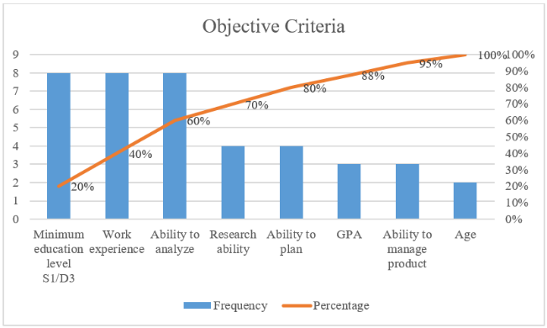

Figure 1 Pareto diagram for objective criteria

The subjective criteria were reduced to 4 criteria namely interpersonal skills, mastery of software, ability to solve problems, the ability to speak spoken and written English as shown in Figure 2.

Figure 2 Pareto diagram of subjective criteria

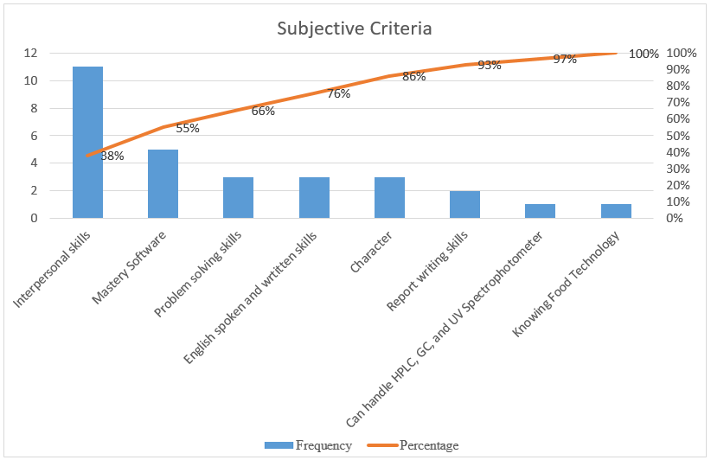**Analytical Hierarchy Process (AHP) Consistency Test**

The reduced criteria are assessed in advance for the level of importance by an expert who is a professional research and development practitioner in PT. Mandom Indonesia. The data on the level of importance of the criteria obtained through the questionnaire was subjected to a consistency test before being used in calculating the weight of the criteria. The results of the consistency test showed that the level of importance of the data was consistent with the consistency ratio value of the objective criteria was 0.07 and the consistency ratio value for subjective criteria was 0.07 which still below the 0.1 threshold value.

**Fuzzy Analytical Hierarchy Process (FAHP)**

To determine the weight of the criteria based on the level of importance of the criteria, the FAHP method is used. The criterion level of importance data will be converted using the previous Fuzzy conversion scale before the calculation is carried out. Calculations using the FAHP are carried out to assign weight of each criterion. Table 2 and Table 3 summarize the weights for objective and subjective criteria respectively.

Table 2 Objective criteria weights

| Objective Criteria | Weight |
| --- | --- |
| Education level | 0,07 |
| Experience length | 0,12 |
| Analytical capabilities | 0,32 |
| Research capabilities | 0,27 |
| Planning capabilities | 0,22 |

Table 3 Subjective criteria weights

| Subjective Criteria | Weight |
| --- | --- |
| Interpersonal skill | 0,32 |
| Software mastery | 0,03 |
| Problem solving skill | 0,47 |
| English language skill | 0,18 |

Scoring system

The known weights become the basis of the system for calculating the value of conformity. Each group of criteria has sub criteria, in the scoring system each sub criterion is represented by one question that must be answered according to the answer choices given. Each answer has its own value, which later the scores of each sub-criterion question will be averaged and become the value of the criteria group. The value of each group of criteria are then multiplied by the weight that has been determined and then the total value for the categories of objective and subjective criteria is sought. The total values of the objective and subjective criteria categories are averaged to find the percentage value of the respondent's fitness with the R&D job position for PT. Mandom Indonesia. The scoring system details are listed in Table 4 (objective criteria) and Table 5 (subjective criteria).

The scoring system was created using the Microsoft Excel application and contains an initial section containing personal data, a content section containing questions, and the final section containing the percentage value of matches. Questions in the content section are answered by selecting the answers provided in the dropdown list. An example of filled application is shown in Figure 3.

**5 CONCLUSIONS**

In this study, the criteria were obtained from the website for job vacancies from 8 manufacturing industry companies with a total of 64 criteria. The criteria that have been collected are grouped based on categories and understanding, so that the objective and subjective criteria groups each amount to 8 groups of criteria. After grouping, the criteria were reduced so that the objective criteria became 5 criteria groups and the subjective criteria became 4 criteria groups. Each criterion is weighted using the FAHP based on the level of importance data obtained from professionals of PT. Mandom Indonesia which has been tested for consistency. The weights of the criteria are used as the basis for making the scoring system. The assessment system was built in the form of a questionnaire using the Microsoft Excel application. When fully filled, the system can compute the fitness percentage for a candidate with R&D Job position.

Since R&D is only one of many functions in a company, this research can be further improved by exploring the other functions as well such as marketing, finance, production, and others. Furthermore, once the models for the other functions are developed, a complex talent pool selection can be developed as well to group the employees based on their suitability for each function.

Table 4 Objective criteria scoring system

| Criteria Group | Criteria | Score | Weight |
| --- | --- | --- | --- |
| Education Level | Bachelor of Industrial Engineering | 100 | 0,07 |
| Bachelor of Chemical Engineering | 100 |
| Bachelor of Mechanical Engineering | 100 |
| Other Bachelor of Engineering | 100 |
| Bachelor of Food Technology | 100 |
| Bachelor of Management | 100 |
| Bachelor of Statistics | 100 |
| Bachelor of Bio Technology | 100 |
| Bachelor of Pharmaceuticals | 100 |
| Other Bachelor Degree | 100 |
| Diploma in Industrial Engineering | 0 |
| Diploma in Design | 0 |
| Work Experience | Fresh Graduate | 25 | 0,12 |
| Experience 1 year | 50 |
| Experience 2 years | 75 |
| Experience ≥ 3 years | 100 |
| Analytical Capabilities | Data Analytics: Grade in Operational Research Course | A= 100, AB= 80, B = 60, BC = 40, C = 20, D-E = 0 | 0,32 |
| Market and trend analysis: grade in Marketing Management Course |
| Numerical Interpretation: grade in Optimization Mathematics |
| Research Capabilities | Research and experiment: grade in Physical Practicum | A= 100, AB= 80, B = 60, BC = 40, C = 20, D-E = 0 | 0,27 |
| Creating research budget: grade in Cost Analysis |
| Research Methods: Grade in Industrial Statistics 2 |
| Planning Capabilities | Priorities setting: Grade in Production Planning and Control Course | A= 100, AB= 80, B = 60, BC = 40, C = 20, D-E = 0 | 0,22 |
| Effective planning: Grade in Production Planning and Control Course |
| Project Management: Grade in Industrial Planning Course |

Table 5 Subjective criteria scoring system

|  |  |  |  |
| --- | --- | --- | --- |
| Criteria Group | Criteria | Score | Weight |
| Interpersonal Skill | Ability to work with target and under pressure | 1 = 0, 2 = 25, 3 = 50, 4 = 75, 5 = 100 | 0,32 |
| Ability to cooperate in teamwork |
| Innovative and Creative |
| Logical thinking |
| Energetic |
| Meticulous |
| Initiative |
| Software mastery | SPS**S** | 1 = 0, 2 = 25, 3 = 50, 4 = 75, 5 = 100 | 0,03 |
| Ms. Project |
| Ms. Office |
| Problem Solving Skill | Brainstorming | 1 = 0, 2 = 25, 3 = 50, 4 = 75, 5 = 100 | 0,47 |
| Working problems with target |
| Ability to create solution |
| Language skill | Verbal and Written English Language Skill | 1 = 0, 2 = 25, 3 = 50, 4 = 75, 5 = 100 | 0,18 |

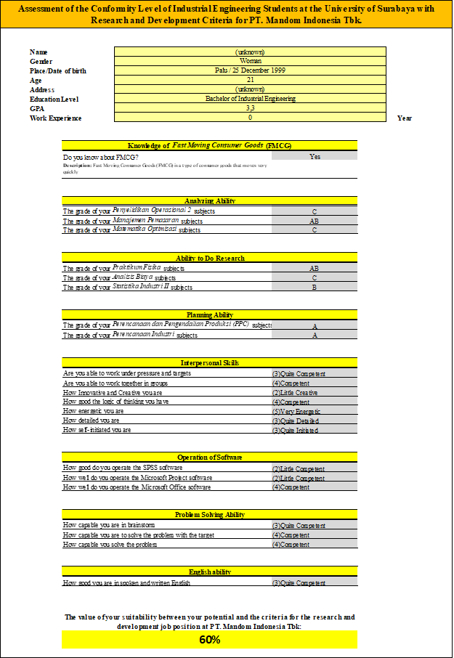

Figure 3 Scoring system interface

**AcKNOWLEDGEMENT**

This research is fully funded by the Directorate of Higher Education in Ministry of Education, Culture, Research, and Technology Republic of Indonesia under contract number: 005/SP-Lit/LPPM-01/RistekBRIN/Multi/FT/III/2021.

**References**

Büyüközkan, G., Feyzioǧlu, O., & Nebol, E. (2008). Selection of the strategic alliance partner in logistics value chain. *International Journal of Production Economics*, *113*(1), 148–158. https://doi.org/10.1016/j.ijpe.2007.01.016

Chen, Z. Y., & Dai, Z. H. (2021). Application of group decision-making AHP of confidence index and cloud model for rock slope stability evaluation. *Computers and Geosciences*, *155*. https://doi.org/10.1016/j.cageo.2021.104836

Chiesa, V., Frattini, F., Lazzarotti, V., & Manzini, R. (2009). Performance measurement of research and development activities. *European Journal of Innovation Management*, *12*(1), 25–61. https://doi.org/10.1108/14601060910928166

Coffey, L., & Claudio, D. (2021). In defense of group fuzzy AHP: A comparison of group fuzzy AHP and group AHP with confidence intervals. *Expert Systems with Applications*, *178*. https://doi.org/10.1016/j.eswa.2021.114970

Collings, D. G., & Mellahi, K. (2009). Strategic talent management: A review and research agenda. *Human Resource Management Review*, *19*(4), 304–313. https://doi.org/10.1016/j.hrmr.2009.04.001

Hashemi, A., Bagher Dowlatshahi, M., & Nezamabadi-pour, H. (2021). A pareto-based ensemble of feature selection algorithms. *Expert Systems with Applications*, *180*. https://doi.org/10.1016/j.eswa.2021.115130

Mulliner, E., Malys, N., & Maliene, V. (2016). Comparative analysis of MCDM methods for the assessment of sustainable housing affordability. *Omega (United Kingdom)*, *59*, 146–156. https://doi.org/10.1016/j.omega.2015.05.013

Oshri, I., & Ravishankar, M. N. (2014). Industry insight: On the attractiveness of the UK for outsourcing services. *Strategic Outsourcing*, *7*(1), 18–46. https://doi.org/10.1108/SO-11-2013-0022

1.  https://orcid.org/0000-0002-6118-6094
2.  https://orcid.org/0000-0002-9653-604X
3.  https://orcid.org/ 0000-0002-3866-8132